NOTICE ANNUAL GENERAL MEETING

Notice is hereby given that the 67th Annual General Meeting of the members of Grandviews Bowling & Recreation Club Ltd will be held on the Club premises, 821 Forest Rd, Peakhurst, on Sunday 3rd November 2024 at 9.30am.

The business of the Annual General meeting shall be as follows:
- to confirm the minutes of the Annual General Meeting of members held on Sunday 5th November 2023
- to receive and consider the Balance Sheet and Financial Statements for the year ended 30th June 2024, the directors report and the auditor’s report
- Ordinary Resolutions
- Life Membership
- General Business

By Resolution and Direction of the Board
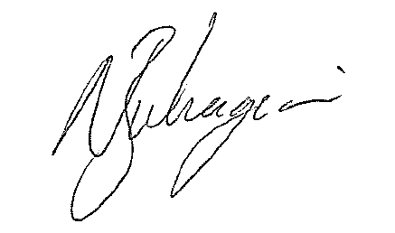
Nathan Buhagiar
General Manager

Note to Members: Questions regarding the Annual Report must be in writing and received by the Club no later than 14 days prior to the Annual General Meeting.

